Press Release

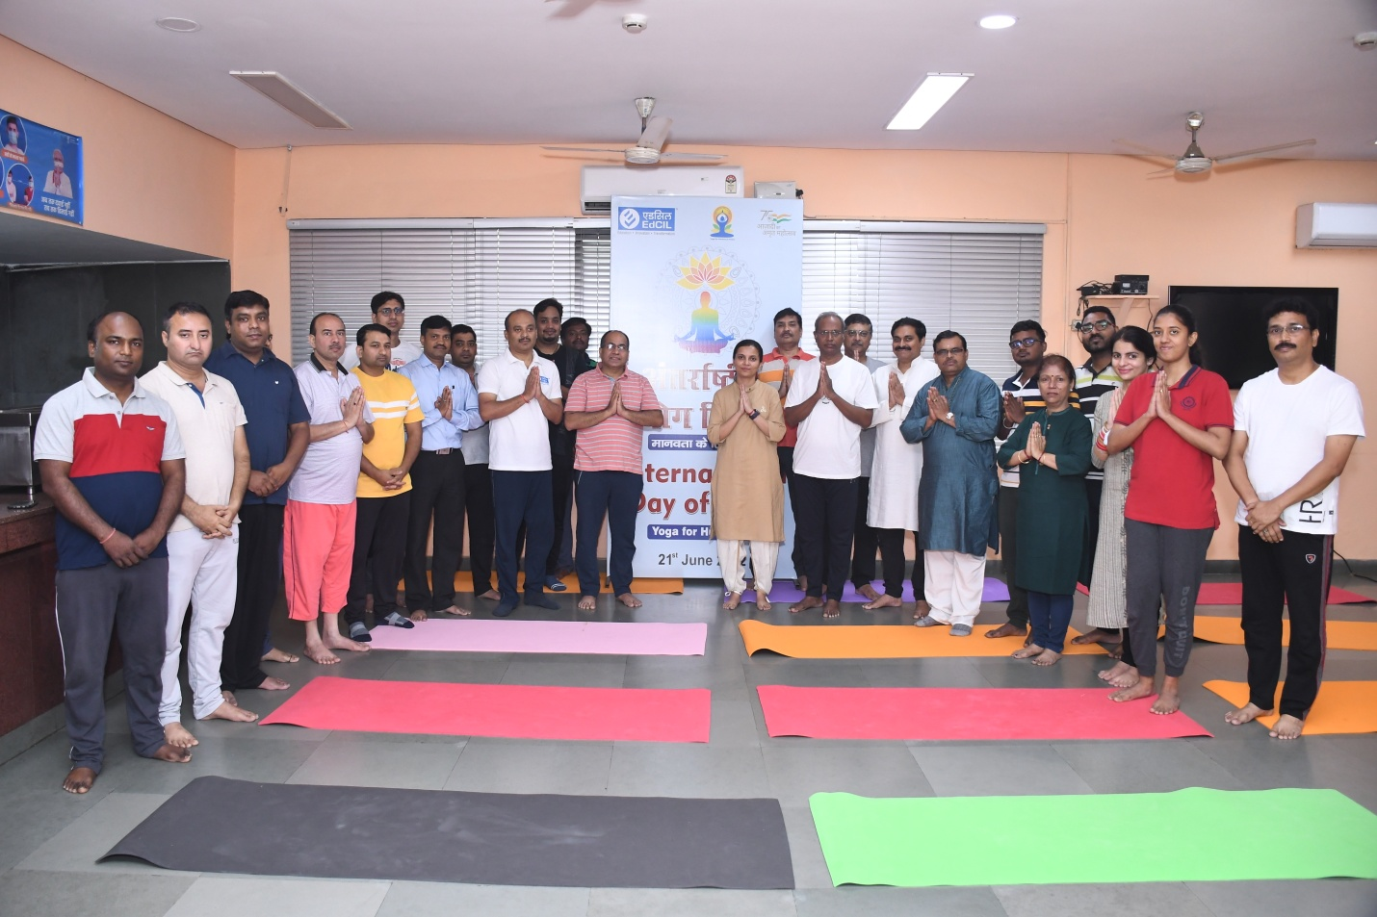

EdCIL (India) Limited celebrated the International Day of Yoga -2022 on 21st June, 2022 at its Corporate Office in Noida. Sh. Manoj Kumar, Chairman & Managing Director along with senior officers and employees participated enthusiastically in the event. A prominent Yoga expert helped participants in undertaking Yoga activities and explained various useful yoga Asanas, mediation and chanting to overcome occupational health issues.

